|  |  |  |
| --- | --- | --- |
|  | Atos – For Internal Use |  |
| Copyright © 2016 Atos India Private Limited. | | |

|  |
| --- |
| Version 1.0 |

|  |
| --- |
|  |

|  |
| --- |
| **HUL Dashboard**  **Analytics** |

|  |
| --- |
|  |

All rights reserved. Reproduction in whole or in part is prohibited without the prior written consent of the copyright owner.

Document control

Issue control

|  |  |  |
| --- | --- | --- |
| Author | Role | Version/Date |
| **Kiran Joshi** | Sr. Angular Js (Front-end UI)Developer | **1.0** on **05/05/216** |
|  |  |  |
|  |  |  |
|  |  |  |

|  |  |  |
| --- | --- | --- |
| Reviewers | Role | Release Date |
|  |  |  |
|  |  |  |
|  |  |  |

Version history

|  |  |  |
| --- | --- | --- |
| Version | Date | Comment |
| 1.0 | 05/05/2016 | Initial version With Level Management | |
|  |  |  |
|  |  |  |
|  |  |  |
|  |  |  |

Contents

1. Introduction 4

1.1 Purpose 4

1.2 Scope of this document 4

1.3 Version & Technology Used 4

1.4 Definitions, Acronyms and Abbreviations 4

2. Project Introduction Error! Bookmark not defined.

2.1 Introduction **Error! Bookmark not defined.**

3. Login 6

4. Regional Trend 9

5. India Compliance Monitoring 15

6. Pan India Compliance 16

7. Temperature Trend 17

8. Appendix 18

8.1 Appendix A – Regional & Temperature Trend 18

8.2 Appendix B – Pan India Compliance 18

8.3 Appendix C – India Compliance Monitoring 18

# Introduction

## Purpose

## This Document helps the user to understand the business discovery with the help of temperature values & it Covers HUL Dashboard Analytics Tool in Below Trend

* Regional Trend
* Pan India Compliance Trend
* India Compliance Monitoring
* Temperature Trend

## Scope of this document

The Document provides an overview of HUL Dashboard Analytics with different trend Types. It Contains Flow Of HUL Dashboard & also It Contains How Internally This Analytics Tool is Working

## Version & Technology Used

| No | Technology | Version/Date |
| --- | --- | --- |
|  | Angular JS | 1.4.7 |
|  | Bootstrap | 3.3.2 |
|  | Google Chart | - |
|  | Spring Framework | 3.2.2 |

## Definitions, Acronyms and Abbreviations

| No | Abbreviations | Description |
| --- | --- | --- |
|  |  |  |
|  |  |  |

# Project Introduction

## Introduction

Atos is providing a web Solution that endures the business discovery for HUL through temperature values. Atos has installed sensors in HUL cold storage (one sensor per device) and these sensors are programmed to send temperature values to Atos cloud, at specified intervals.

This data is stored in the Internet of Things (IoT) database and is used by Analytics Tool – Angular JS & Java Spring We are Use d& Provide One Web Solutions To Analytics & generate reports.

## 

# Login

To login to the system, enter the following URL in the address bar and click **Enter**

<http://115.112.94.53:11023/huldashboard/#/login> **UAT**

<http://feetonstreet.atosicloud.com/huldashboard/#/login> **Production**

When any One Of Above URL Hits

Firstly it checks in web.xml to fetch the corresponding page

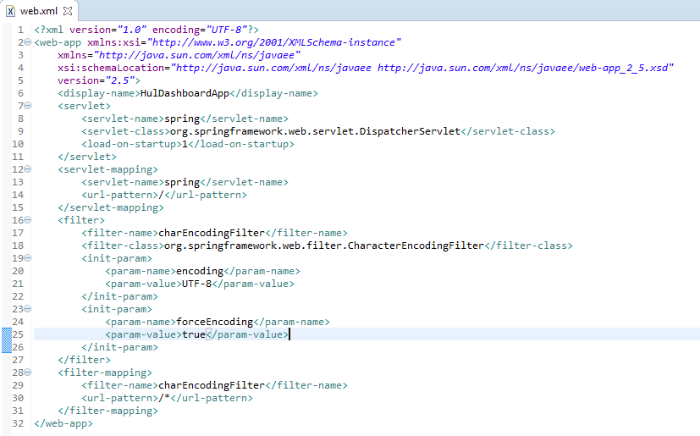

So here it finds that we have one more xml(spring-servlet.xml) which handles the page redirection.

Here in spring-servlet.xml it finds :

1. <context:component-scan base-package="net.hul.dashboard" />

In all controllers it will search for method having RequestMapping(“/”).

We have written this requestMapping in BasicDashBoardController.java

@RequestMapping(value="/" , method = RequestMethod.*GET*)

public String loginPage(ModelMap map) {

map.addAttribute("name","HUL");

return "main";

}

2)Once it gets which jsp page to be redirected, it finds path where the jsp can be found again from the spring-servlet.xml

<bean id=*"jspViewResolver"*

class=*"org.springframework.web.servlet.view.InternalResourceViewResolver"*>

<property name=*"viewClass"*

value=*"org.springframework.web.servlet.view.JstlView"* />

<property name=*"prefix"* value=*"/jsp/"* />

<property name=*"suffix"* value=*".jsp"* />

</bean>

So it fetches the main.jsp page on the screen

----------------------------------------------------------------------------------

This main.jsp is the basic(main)page which contains entries of all the css files ,js files used in the project.

In this jsp we have “<div ng-view></div>”

This by default first redirects to “/login”

For this redirection we have made an entry in app.js file

var myApp = angular.module('hul', ['am.multiselect','ngRoute','Authentication',

'ngCookies','myApp.directives']).config(['$routeProvider','$httpProvider', function ($routeProvider, $httpProvider) {

$routeProvider.

when('/login', {templateUrl: tempContextPath+'/jsp/login.jsp'}).

when('/index/:trendType', {templateUrl: tempContextPath+'/jsp/index.jsp',controller:"charts"}).

otherwise({redirectTo: '/login'});

}]);

This redirects to login.jsp and this page is displayed on browser.



**LoginPage:**

Both fields “Email Address” and “Password” are mandatory.

After clicking “Sign In”, control comes to loginController.js, here it sends the emailId and password to authenticationService.js which finally call webservice of backend

**$http.post(tempContextPath+"/submitLogin",selectedValues).success(function (response) {**

if(response.status == "success"){

}else{

response.message = 'Username or password is incorrect';

}callback(response);});

This (“/submitLogin”) requestMapping is present in **BasicDashBoardController**.java

1)If this method returns failure, User has to fill in the form once again.

2) When emailId and password is matched it fetches the access_zone, access_factory, access_pv, access_depot,access_sv,access_rs_cold_room,access_rsv values and are set in session. Now success is returned to the frontend and here it redirects to index.jsp where-in according to user’s region and cold-chain access, data is sent from backend and accordingly it is replicated in the google charts.

After The Successfully Login on to The System It redirects To Default Trend: **Regional Trend**

Note : We are Providing Analytics In For Trend As Mentioned Below.

* Regional Trend
* Pan India Compliance Trend
* India Compliance Monitoring
* Temperature Trend

# Regional Trend

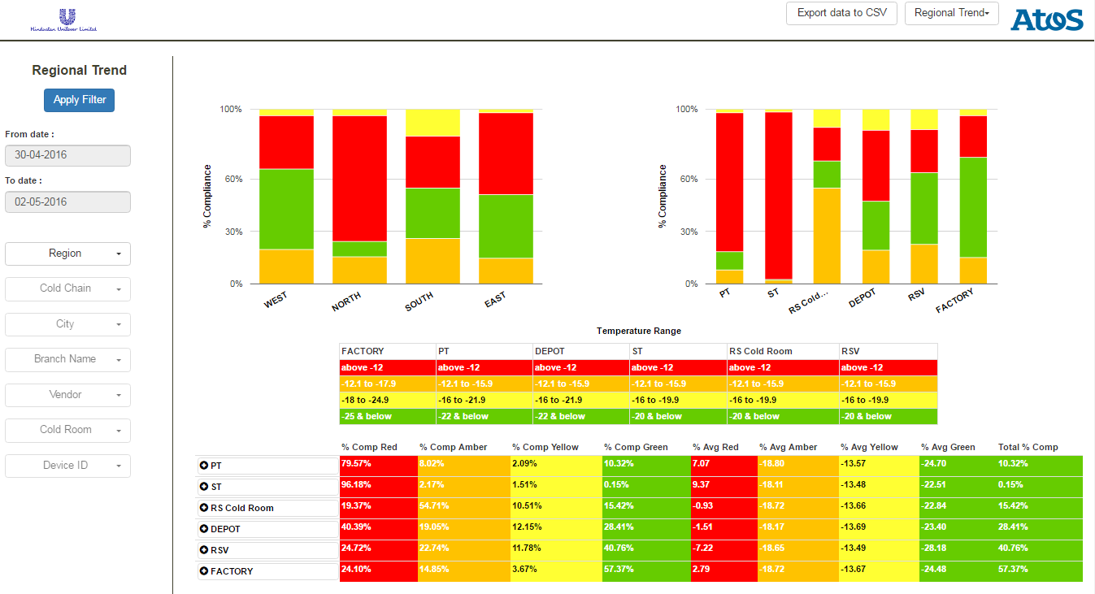

Here from frontend, in order to display the data on this page, it calls 2 backend web services:

1)”/ **roleBasedDropDownData**”:

This web-service fetches data to be shown in LHS dropdown

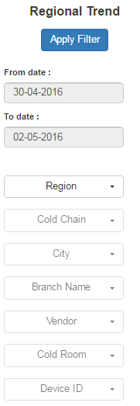

As Mentioned In Below Image function Code which is used to fill dropdown is Exist in **interactive_google_charts.js**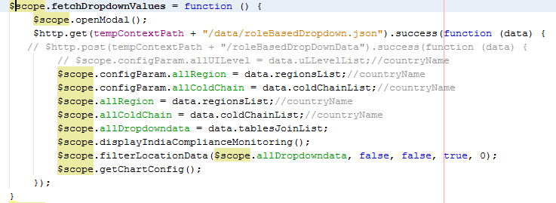

In Above code data.tablesJoinList Content All Data Based On That User (Currently Logged)

This Data passed in filterLocationData Function to set Scope For All Dropdown Based On Their Level

One thing TO Note we are Managing Level Over Here .Means Below Dropdown Only Open If Any Only if Above One Is Selected..

**If You Want TO know about the flow you have 2 be clear About Level Management .There are 2 Types Of Level We Are Managing**

1. Graph Level management
2. LHS dropdown Level Management

As per below image Level Define in $scope.init() Function

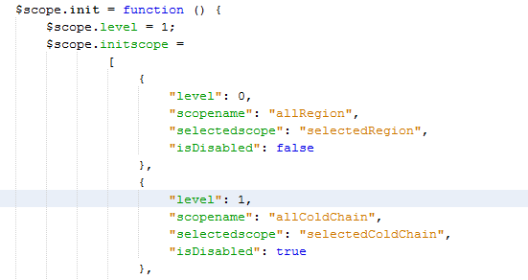

Here $scope.level=1 it indicates Graph Level & level inside $scope.initscope is LHS dropdown Level which is managed by isDisabled parameter, it while change one after other when dropdown is selected

Graph Level:

$scope.level=1 Means Region & Cold chain Graph Will Be Visible

$scope.level=2 Means Region & City Graph Is Visible

$scope.level=3 Means Region & Device Graph is Visible

2)”/**fetchDefaultValues**”:

This web-service fetches data to be shown in RHS for the two charts and data to be shown in table below.

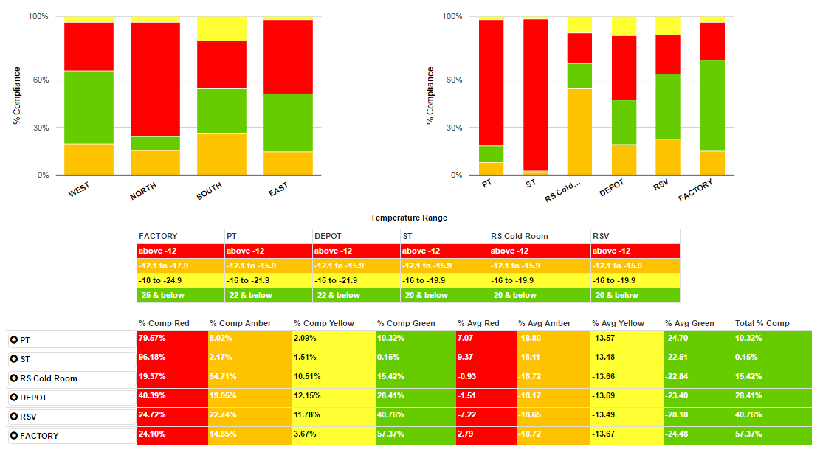

In **webapp/data** folder just open finaloutput.json.. this JSON will come Back from Database when this service is called.

Note : based On webapp/data/temperature.json Which Contains All Temperature Range For All Types Of Trend (ex, Regnal India Complaints , etc.. ) This File Will be load on Init & based On Trend Type It Will Set the Temperature Range & graph is displayed

Other Config JSON file webapp/data/googlecharts.json Also Load In It Which Contain All Google Graph Related Configuration

APPLY Filter Functionality ( **For All Trend it will same**):

When User select values from dropdown or Changes Dates & apply Filter that $scope.applyFilter() Function Is called & in This function First it Which Check Which Level Currently it Is & set Filter data in $scope.selectedFilter in $scope.setSelectedFilter() function After that fetchChartValues Web Service Is called in that in $scope.selectedFilter is passed & it will return Data as sample in webapp/data/finaloutpt.json

**NOTE : When First Time Page Loads at that Time**

**requestName= fetchDefaultValues & when Click On Apply Filter Button requestName= fetchChartValues**

**Webservice**: **$http.post(tempContextPath + "/" + requestName, $scope.selectedFilter).success(function (data) {**

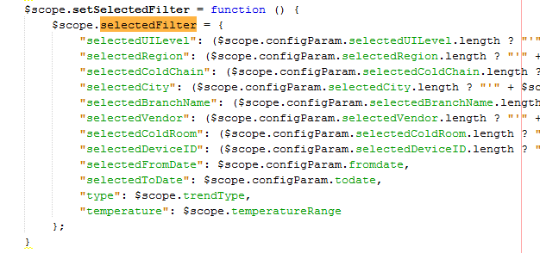

**Graph Level Management for Regional trend:**

1. **$scope.level = 1** : you will see Region & cold Chain Graph

In More You will show city when you click on Cold Chain in table Filter as show in image & when You click On that city $scope.drawSelectdDropdownChartByCity function will be called & Graph will be displayed Based on that city (Note : it will not change the Level but just displayed City Graph)

In Process **fetchDrilledValues** Web Service is called

$http.post(tempContextPath + "/fetchDrilledValues", $scope.selectedFilter).success(function (data) {

& will be return city data data/city-diviceid-map.json

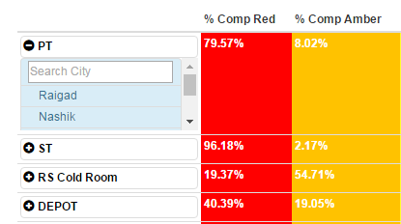

1. **$scope.level = 2** : you will see Region & City Based Graph

Note Whenever You click on Any Cold Chain in First Level : Level is changed to 2 & you are able to see below graph of city

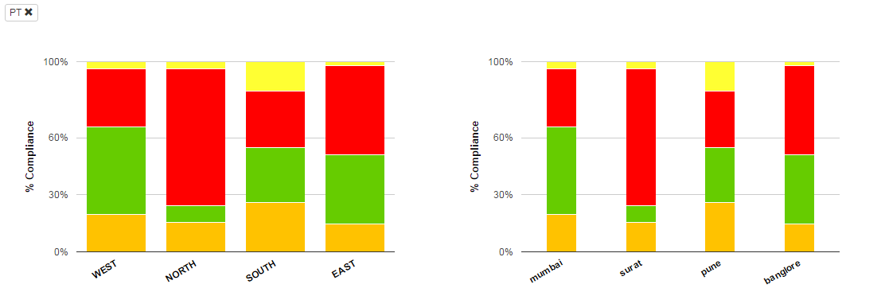

In Process **fetchDrilledValues** Web Service is called

$http.post(tempContextPath + "/fetchDrilledValues", $scope.selectedFilter).success(function (data) {

& will be return city data data/city-diviceid-map.json

In More You will show Device ID when you click on City in table Filter as show in image & when You click On that city $scope.drawSelectdDropdownChartByDevice function will be called & Graph will be displayed Based on that Device (Note : it will not change the Level but just displayed Device Graph)

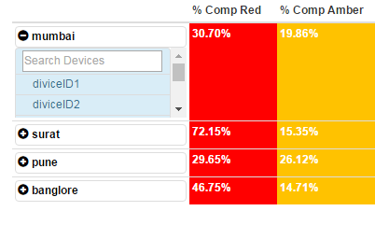

1. **$scope.level = 3** : you will see Region & Device Based Graph

Note: Whenever You click on Any City in Second Level : Level is changed to 3 & you are able to see below graph of Device

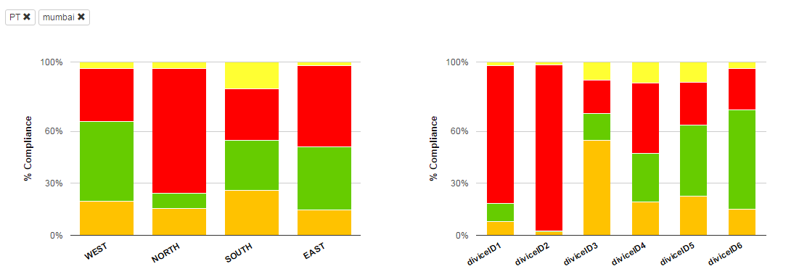

In Process fetchDrilledValues Web Service is called

$http.post(tempContextPath + "/fetchDrilledValues", $scope.selectedFilter).success(function (data) {

& will be return city data data/city-diviceid-map.json

In More You will show all Device ID

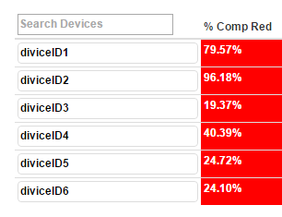

# India Compliance Monitoring

#### If User Has access Of all 4 Regions Then This Trend Is Visible At right end side of the page...

#### Filter Will work same as Mention In Regional Trend

#### $http.post(tempContextPath + "/" + requestName, $scope.selectedFilter).success(function (data) { web service will be called

#### $scope.indiaComplianceMonitoringData = data;// Hold The Backend response data

#### & letter $scope.indiaComplianceMonitoring(); Function is called to Display Graph As Mention In Below Image

#### 

# Pan India Compliance

#### Filter Will work same as Mention In Regional Trend

#### $http.post(tempContextPath + "/" + requestName, $scope.selectedFilter).success(function (data) { web service will be called

#### $scope.panComplianceMonitoringData = data.compliance;// Hold The Backend response data :

#### Sample response

#### $scope.panComplianceMonitoringData = {"FACTORY": 12,"RS Cold Room": 57,"DEPOT": 29,"PT": 49.58,"ST": 23,"RSV": 89,"FACTORYANT": 5,"DEPOTANT": 72}

#### & letter $scope. panIndiaComplianceMonitoring (); Function is called to Display Graph As Mention In Below Image

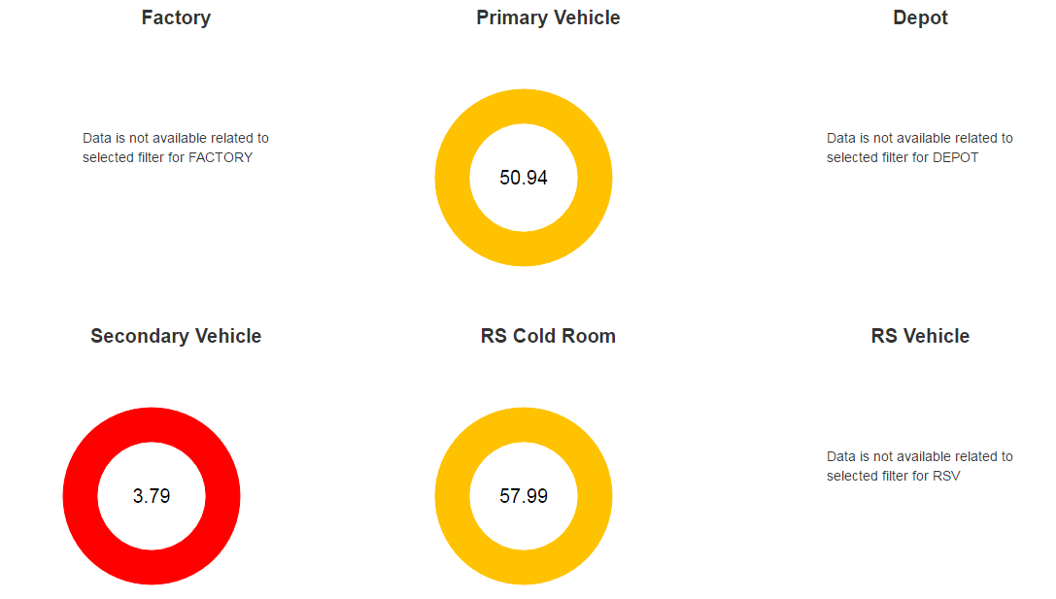

# Temperature Trend

#### Filter Will work same as Mention In Regional Trend

#### $http.post(tempContextPath + "/" + requestName, $scope.selectedFilter).success(function (data) { web service will be called

#### $scope.temperatureData = data.temperature;;// Hold The Backend response data

#### & letter $scope.temperatureTrend(); Function is called to Display Graph As Mention In Below Image

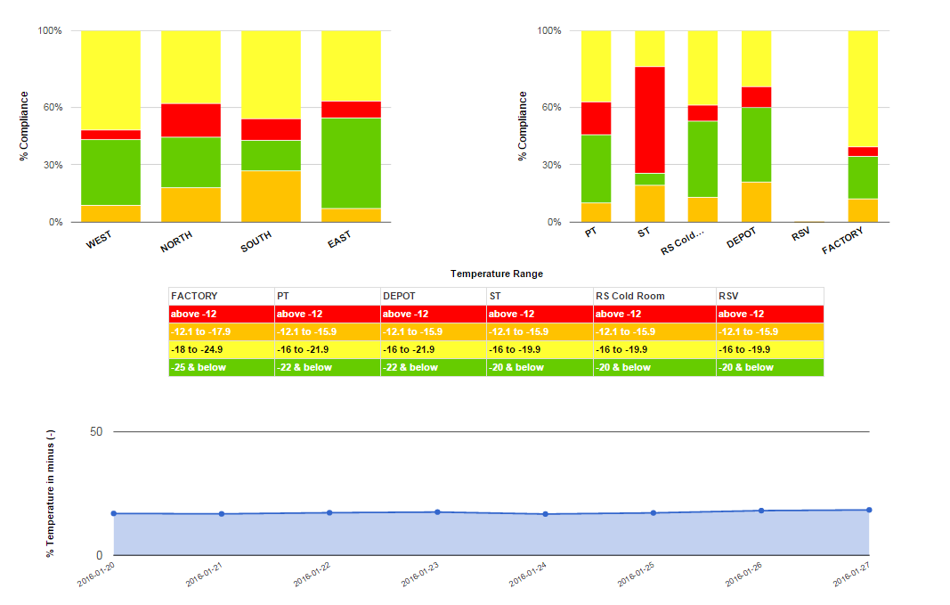

# Appendix

## : Appendix A – Regional & Temperature Trend.

Below is the Temperature Range & colour For Regional & Temperature Trend.

Temperature Range & Colour Wise data You will get in data/temperature.json File

That we are passing from Front-end to web service Based On that data Query is Executed & data Will be return.

This colour array we are ['Amber', 'Green', 'Red', 'Yellow'] displaying in graph based on condition in temperature json .you can clearly show this in below image

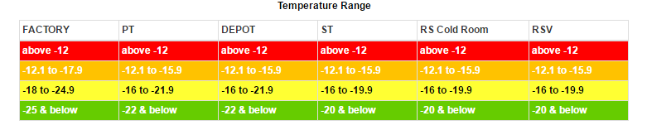

## 8.2 : Appendix B – Pan India Compliance

For Pan India Graph Color Will be Decide as Displayed In below Image

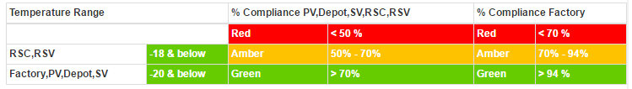

## 8.3 : Appendix C – India Compliance Monitoring

For Pan India Graph Color Will be Decide as Displayed In below Image

